Name: G R Aakaash Slot: A
Reg No: 192412068 Course faculty: Sathish,K

Exp12: NB-IoT vs LTE-M Throughput Simulation
Objective-1: To evaluate and compare the Throughput (Mbps) performance of NB-IoT and LTE-M
under varying network conditions.
CODE: clc;
clear;
close all;
% SNR values (dB)
SNR = 0:5:30;
% Simulated Throughput (Mbps)
NB_IoT = 0.05*(1-exp(-SNR/8));
LTE_M = 1.2*(1-exp(-SNR/8));

disp('SNR (dB) NB-IoT(Mbps) LTE-M(Mbps)')
disp([SNR' NB_IoT' LTE_M'])
figure
% -------- Graph 1 --------
subplot(2,1,1)
plot(SNR,NB_IoT,'-o','LineWidth',2)
title('NB-IoT Throughput vs SNR')
xlabel('Signal-to-Noise Ratio (dB)')
ylabel('Throughput (Mbps)')
grid on
% -------- Graph 2 --------
subplot(2,1,2)
plot(SNR,LTE_M,'-s','LineWidth',2)
title('LTE-M Throughput vs SNR')
xlabel('Signal-to-Noise Ratio (dB)')
ylabel('Throughput (Mbps)')
grid on
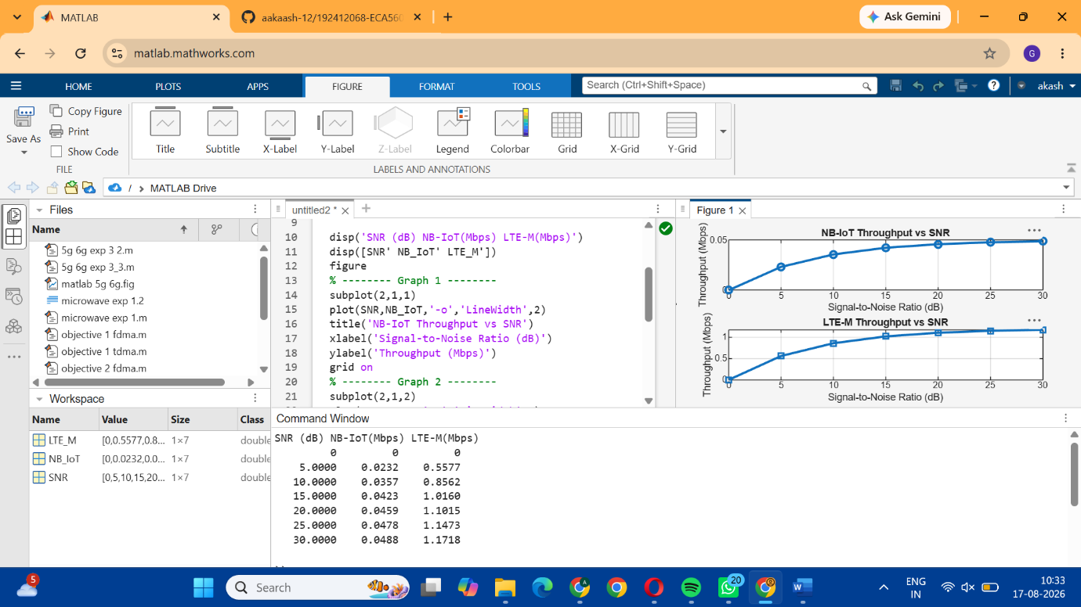

Objective-2: To analyze the Latency (ms) characteristics of NB-IoT and LTE-M and study their
impact on real-time communication.
Code: clc;
clear;
close all;
% SNR values (dB)
SNR = 0:5:30;
% Simulated Latency (ms)
NB_IoT = [180 160 145 130 120 110 100];
LTE_M = [90 80 70 60 50 45 40];
disp('SNR(dB) NB-IoT Latency(ms) LTE-M Latency(ms)')
disp([SNR' NB_IoT' LTE_M'])
figure
% -------- Graph 1 --------
subplot(2,1,1)
plot(SNR,NB_IoT,'-o','LineWidth',2)
title('NB-IoT Latency vs SNR')
xlabel('Signal-to-Noise Ratio (dB)')
ylabel('Latency (ms)')
grid on
% -------- Graph 2 --------
subplot(2,1,2)
plot(SNR,LTE_M,'-s','LineWidth',2)
title('LTE-M Latency vs SNR')
xlabel('Signal-to-Noise Ratio (dB)')
ylabel('Latency (ms)')
grid on
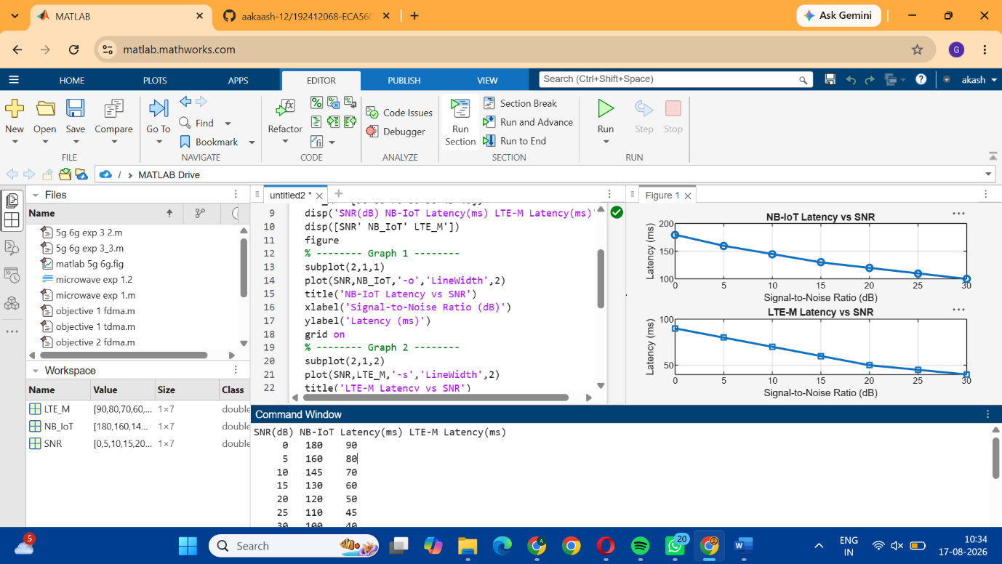

Objective-3: To measure and compare the Packet Delivery Ratio (%) of NB-IoT and LTE-M
systems for reliability assessment.

Code: clc;
clear;
close all;
% SNR values (dB)
SNR = 0:5:30;
% Simulated Packet Delivery Ratio (%)
NB_IoT = [82 86 89 92 95 97 99];
LTE_M = [88 91 94 96 98 99 100];
disp('SNR(dB) NB-IoT PDR(%) LTE-M PDR(%)')
disp([SNR' NB_IoT' LTE_M'])
figure
% -------- Graph 1 --------
subplot(2,1,1)
plot(SNR,NB_IoT,'-o','LineWidth',2)
title('NB-IoT Packet Delivery Ratio vs SNR')
xlabel('Signal-to-Noise Ratio (dB)')
ylabel('Packet Delivery Ratio (%)')
grid on
% -------- Graph 2 --------

subplot(2,1,2)
plot(SNR,LTE_M,'-s','LineWidth',2)
title('LTE-M Packet Delivery Ratio vs SNR')
xlabel('Signal-to-Noise Ratio (dB)')
ylabel('Packet Delivery Ratio (%)')
grid on
